ASSIGNMENT NUMBER: 5
SUBJECT: OBJECT ORIENTED PROGRAMMING

Name: SHRIRANG MHALGI
Class: S.E.
Division: B
Roll no: 222006
Batch: B1

PROBLEM STATEMENT:
Employee bio data using following classes: -
1. Personal record.
2. Professional record.
3. Academic record.
Assume appropriate data members and member functions to accept and display required data and at the end display the complete bio data of employee. Use multiple inheritances in C++.

CONCEPTS:
Inheritance

THEORY:
Inheritance in Object Oriented Programming can be described as a process of creating new classes from existing classes. New classes inherit some of the properties and behavior of the existing classes. An existing class that is "parent" of a new class is called a base class. New class that inherits properties of the base class is called a derived class. Inheritance is a technique of code reuse. It also provides possibility to extend existing classes by creating derived classes.
The basic syntax of inheritance is:
Class Derived_Class : Access_Specifier Base_Class

There are 3 access specifiers:
Namely public, private and protected.

public:
This inheritance mode is used mostly. In this the protected member of Base class becomes protected members of Derived class and public becomes public.

protected:
In protected mode, the public and protected members of Base class becomes protected members of Derived class.

private:
In private mode the public and protected members of Base class become private members of Derived class.

TYPES OF INHERITANCE:
In C++, we have 5 different types of Inheritance. Namely,
- Single Inheritance
- Multiple Inheritance
- Multilevel Inheritance
- Hybrid Inheritance
- Hierarchical Inheritance

1. SINGLE INHERITANCE
In this type of inheritance one derived class inherits from only one base class. It is the simplest form of Inheritance.
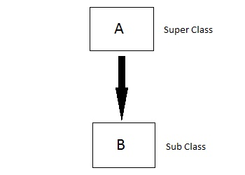

2. MULTIPLE INHERITANCE
In this type of inheritance a single derived class may inherit from two or more than two base classes.
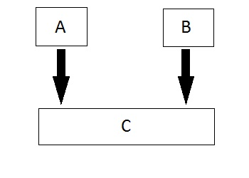
3. MULTILEVEL INHERITANCE
In this type of inheritance the derived class inherits from a class, which in turn inherits from some other class. The Super class for one is sub class for the other.
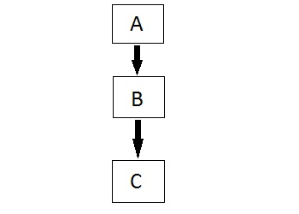

4. HYBRID INHERITANCE
Hybrid Inheritance is combination of any 2 or more types of inheritances.

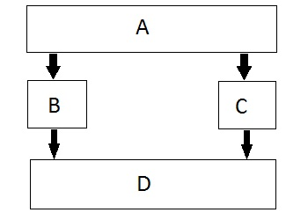

5. HIERARCHICAL INHERITANCE
In this type of inheritance, multiple derived classes inherit from a single base class.
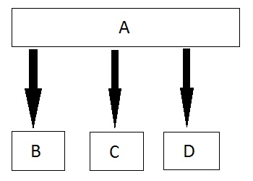

ALGORITHM:
1. Start.
2. Create a class named personal_record.
3. Declare data members name, add, dob, email, phone as private members of the class.
4. Declare public members: get_per_rec() to accept values from user, put_per_rec() to display the values.
5. Create another class named professional_record.
6. Declare data members empid desig, join, depart, salary, exp as private members of the class.
7. Declare public members : get_prof_rec() accept values from user, put_prof_rec() to display the values.
8. Create another class named academic_record which privately inherites data from class personal_record and professional_record.
9. Declare data members empid, desig, join, depart, salary, exp as private members of the class.
10. Declare public members : get_aca_rec() accept values from user, put_aca_rec() to display the values.
11. In main function create object of class academic_record obj.
12. Using obj access get_per_rec(), get_prof_rec() and get_aca_rec() to accept input from user.
13. Using obj access put_per_rec(), put_prof_rec() and put_aca_rec() to display the inputted data.
14. Stop.

STATE TRANSITION DIAGRAM:

Q0 à Q1 à Q2 à Q3 à Q4 à Q5 à Q6 à
Qe

Q0 – Start program, initialize variables.
Q1 –call function get_per_rec() which originally belonged to personal_record using object of academic_record.
Q2 –call function get_prof_rec() which originally belonged to professional_record using object of academic_record.
Q3 –call function get_aca_rec() belonging to academic_record using object of academic_record.
Q4 –call function put_per_rec() which originally belonged to personal_record using object of academic_record.
Q5 –call function put_prof_rec() which originally belonged to professional_record using object of academic_record.
Q6 –call function put_aca_rec() which belongs academic_record using object of academic_record.
Qe –end of program.

CODE:
#include<iostream>
#include <limits.h>
using namespace std;
class Personal
{
public : char name[50],address[100];
long long int mobile;
char dob[15],nationality[20],sex[10];
int personal()
{
cin.clear();
cout<<"enter your personal record"<<endl;
cout<<"enter name"<<endl;
cin.getline(name,50);
cout<<"enter your date of birth"<<endl;
cin.getline(dob,15);
cout<<"enter your address"<<endl;
cin.getline(address,100);
cout<<"enter your nationality "<<endl;
cin>>nationality;
cout<<"enter your sex"<<endl;
cin>>sex;
cout<<"enter your mobile number"<<endl;
cin>>mobile;
cin.ignore(INT_MAX,'\n');
return 0;
}
};
class Qualifications
{
public : char schoolName[50],collegeName[50],institute[50];
int sPass,cPass,iPass;
int qualifications()
{
cout<<"enter your qualifications "<<endl;
cout<<"enter your school name "<<endl;
cin.getline(schoolName,50);
cout<<"enter your college name "<<endl;
cin.getline(collegeName,50);
cout<<"enter your institute name "<<endl;
cin.getline(institute,50);
cout<<"enter your year of passing school "<<endl;
cin>>sPass;
cout<<"enter your year of passing college "<<endl;
cin>>cPass;
cout<<"enter your year of passing institute "<<endl;
cin>>iPass;
return 0;
}
};
class Academics
{
public : float fe,se,te,be,avg;
int academics()
{
cout<<"enter your academnic details"<<endl;
cout<<"enter your first year pointer "<<endl;
cin>>fe;
cout<<"enter your second year pointer "<<endl;
cin>>se;
cout<<"enter your te pointer "<<endl;
cin>>te;
cout<<"enter your be pointer "<<endl;
cin>>be;
avg = (fe+se+te+be)/4;
return 0;
}
};
class Display : public Personal, public Academics,public Qualifications
{
public : int display()
{
cout<<"\n\n\n\n\t\t\t***** YOUR BIODATA IS *****"<<endl;
cout<<"1. Personal record :"<<endl;
cout<<"\t\tName :"<<name<<endl;
cout<<"\t\tDate of birth :"<<dob<<endl;
cout<<"\t\tAddress :"<<address<<endl;
cout<<"\t\tSex :"<<sex<<endl;
cout<<"\t\tMobile :"<<mobile<<endl;
cout<<"--------------------------------------------------------------------------------------------------"<<endl;
cout<<"2. Qualifications :"<<endl;
cout<<"\t\tSchool name :"<<schoolName<<endl;
cout<<"\t\tYear of passing :"<<sPass<<endl;
cout<<"\t\tCollege name :"<<collegeName<<endl;
cout<<"\t\tYear of passing :"<<cPass<<endl;
cout<<"\t\tInstitute name :"<<institute<<endl;
cout<<"\t\tYear of passing :"<<iPass<<endl;
cout<<"--------------------------------------------------------------------------------------------------"<<endl;
cout<<"3. Academics"<<endl;
cout<<"\tResult:"<<endl;
cout<<"\t\tFirst year :"<<fe<<endl;
cout<<"\t\tSecond year :"<<se<<endl;
cout<<"\t\tThird year :"<<te<<endl;
cout<<"\t\tFourth year :"<<be<<endl;
cout<<"\t\tAverage :"<<avg<<endl;
cout<<"--------------------------------------------------------------------------------------------------"<<endl;
return 0;
}
};
int main()
{
Display p1;
p1.personal();
p1.qualifications();
p1.academics();
p1.display();
return 0;
}
OUTPUT:
enter your personal record
enter name
shrirang mhalgi
enter your date of birth
9/4/1998
enter your address
Pune india
enter your nationality
indian
enter your sex
male
enter your mobile number
9876543210
enter your qualifications
enter your school name
modern high school
enter your college name
fergussion college
enter your institute name
viit
enter your year of passing school
2010
enter your year of passing college
2012
enter your year of passing institute
2016
enter your academnic details
enter your first year pointer
10
enter your second year pointer
8
enter your te pointer
9
enter your be pointer
7

***** YOUR BIODATA IS *****
1. Personal record :
Name :shrirang mhalgi
Date of birth :9/4/1998
Address :Pune india
Sex :male
Mobile :9876543210
--------------------------------------------------------------------------------------------------
2. Qualifications :
School name :modern high school
Year of passing :2010
College name :fergussion college
Year of passing :2012
Institute name :viit
Year of passing :2016
--------------------------------------------------------------------------------------------------
3. Academics
Result:
First year :10
Second year :8
Third year :9
Fourth year :7
Average :8.5
--------------------------------------------------------------------------------------------------

Press any key to continue . . .

CONCLUSION:

We have learnt the following concepts:
- Implementation of inheritance.
- Types of inheritance.
- Access specifiers.
- How to access derived members using object of inherited class.

